Grammar-Based Fuzzing for Software Security Testing
  - Authors: Siddiq Husain Tashfeen & Tanzim Rahman

Abstract
The foundation of automated software security testing relies heavily on mutational fuzzing; however, traditional techniques face a severe "syntactic bottleneck" when targeting highly structured data formats like JSON. Random byte-level mutations typically generate syntactically invalid inputs that are immediately rejected by a parser, preventing the discovery of deep semantic vulnerabilities [1], [5]. This project introduces a deterministic, grammar-based fuzzer specifically engineered to bypass these initial validation checks. By utilizing a manually defined Context-Free Grammar (CFG) compliant with RFC 8259, our architecture generates syntactically flawless JSON payloads via an in-memory Abstract Syntax Tree (AST) node structure. To test resilience, the system applies AST-level semantic mutations prior to serialization, including boundary value injection, forced nesting, and string anomalies. Deployed against Python’s built-in json module, a 5000-iteration campaign was executed natively in just 0.89 seconds (and 7.10 seconds under full instrumentation), achieving an 85% code coverage across the fuzzer ecosystem. The pipeline successfully parsed 2,949 valid inputs while leveraging cryptographic crash deduplication to isolate 2 unique critical vulnerabilities (primarily recursion depth exhaustion) filtered from 672 duplicate instances. These results demonstrate that a structurally aware fuzzing pipeline can achieve massive edge-case discovery without the immense computational overhead associated with automated grammar inference engines [7].

1. Introduction

1.1 Background
Fuzzing is a fundamentally critical software testing technique that feeds semi-random inputs to a target program to uncover unexpected behaviors, crashes, and memory leaks. In the security domain, fuzzers are generally categorized into two methodologies: mutational (coverage-guided) and generational (grammar-based) [5]. Mutational fuzzers, such as AFL or LibFuzzer, excel at finding memory corruption vulnerabilities in C/C++ programs by randomly flipping bits and bytes. Generational fuzzers, conversely, build payloads from scratch using strict grammatical rules, resulting in syntactically flawless outputs [6].

1.2 The Syntactic Bottleneck Challenge
While traditional mutational fuzzing performs exceptionally well on straightforward applications, it faces a severe limitation known as the "syntactic bottleneck" when targeting programs that process structured data, such as JSON, XML, or programming languages [1]. Random byte-level mutations almost exclusively generate syntactically invalid inputs. Consequently, the target application's initial parser immediately rejects these inputs, preventing the fuzzer from exploring deep, semantic execution paths and leaving critical logical vulnerabilities unexamined.

1.3 Project Objectives
To address this challenge, the field has transitioned toward grammar-based fuzzing, which utilizes formal context-free grammars (CFGs) to ensure payloads bypass initial parser validations [5]. This project aims to bridge the gap between structural validity and vulnerability discovery by developing a custom Python-based CFG fuzzer targeting JSON parsers. By implementing a highly controlled, manually defined CFG environment combined with AST-level deterministic mutation strategies, this project seeks to overcome the syntactic bottleneck while avoiding the computational overhead typical of automated grammar inference [7].

2. Literature Review

2.1 The Syntactic Bottleneck of Traditional Fuzzing
The foundation of automated software testing is rooted in mutational fuzzing, a technique that alters input data at the byte level to trigger unexpected program states. Although traditional fuzzing performs exceptionally well on straightforward target applications, it faces a severe "syntactic bottleneck" when targeting programs that process highly structured data. Random byte-level mutations almost exclusively generate syntactically invalid inputs, which are immediately rejected by the initial parser. This early rejection prevents the fuzzer from exploring deep, semantic execution paths, leaving critical logical vulnerabilities and bugs completely unexamined [1]. Consequently, the field transitioned toward grammar-based fuzzing, which utilizes formal context-free grammars (CFGs) to bypass these initial validations [5], [6].

2.2 The Evolution of Grammar Fuzzing
Early strategies attempted to bypass initial parser rejections by providing random fuzzers with dictionaries of essential format-specific markers, often called 'magic bytes'. However, blindly inserting these tokens proved highly inefficient; it resulted in a poor mutation success rate and failed to meaningfully increase branch coverage relative to computational time. To address this, Dube et al. introduced DictFuzzer, which leverages dynamic taint analysis to track the program's data-flow, identifying the exact byte offsets where dictionary keywords should be mutated [2]. This targeted approach demonstrated significant quantitative success, yielding 12 officially recognized CVEs in real-world programs. However, a critical trade-off is the massive runtime overhead introduced by taint analysis [2]. Furthermore, early grammar-based fuzzers suffered from a lack of "vision", they generated valid inputs but failed to utilize code coverage feedback to guide their mutations. To bridge this gap, Eberlein et al. proposed Evolutionary Grammar-Based Fuzzing (EvoGFuzz) [1]. Algorithmically, EvoGFuzz maps inputs into an Abstract Syntax Tree (AST) and performs subtree mutations, substituting entire AST nodes with alternative valid structures to maintain syntactic correctness while altering semantics [1].
Similarly, pushing the boundaries of input generation, Havrikov introduced the concept of utilizing probabilistic grammars learned from real-world sample inputs [3]. By algorithmically inverting these observed probabilities, the fuzzer intentionally generated syntactically valid but highly unusual inputs (known as "Inputs from Hell"), proving exceptionally effective at triggering unhandled edge cases [3]. Approaches like G-EvoSuite also demonstrated that integrating grammar-driven AST mutations into automated unit testing frameworks improved branch coverage for structured-data classes by an average of 15% [4].

2.3 The Challenge of Grammar Inference and Automation
Despite its efficacy, a major limitation of grammar-based fuzzing is the immense manual effort required to accurately define CFGs for complex targets [5]. Modern research is heavily focused on automating this process. Early attempts at automating grammar inference in black-box settings, such as ARVADA and KEDAVRA, successfully inferred smaller grammars but fundamentally failed to scale to real-world complex languages due to their reliance on parsing full-length input examples and strict no-overgeneralization constraints [7].
To overcome early limitations, tools like GRIMOIRE introduced grey-box grammar inference, dynamically synthesizing structural input chunks on-the-fly using coverage feedback [6]. At the absolute frontier is CRUCIO, a framework that successfully tackles black-box limitations by building a "decomposition forest" to isolate smaller input chunks and then constructs a distributional matrix mapping substrings to parser-accepted contexts [7]. However, while mathematically impressive, these state-of-the-art inference engines require significant computational resources and often generate over-generalized rules that dilute targeted fuzzing efficiency [7].

2.4 The Role of Grammar-Based Fuzzing in Industry
Beyond academic prototypes, grammar-based fuzzing has become a foundational security practice within major technology corporations. Complex parsers integrated into web browsers, cloud infrastructures, and document readers are prime targets for exploitation. Companies like Google, Microsoft, and Mozilla actively employ sophisticated grammar-aware engines (such as DOMato for HTML/DOM engines and libprotobuf-mutator for structured protocols) to uncover critical zero-day vulnerabilities [5]. For instance, Domato has been extensively utilized to find bugs in major web browsers by automatically generating highly structured HTML test files [8].
Furthermore, the industry relies heavily on grammar-based techniques to secure immensely complex systems such as compilers and network infrastructure. In the domain of compiler testing, tools like CSmith, a state-of-the-art grammar-based C program generator, have been used to uncover more than 400 previously unknown bugs in mainstream C compilers [8]. Similarly, corporate research divisions, such as Microsoft, have actively developed machine-learning-assisted grammar fuzzers (like Learn&Fuzz) to specifically stress-test the complex PDF parsers integrated into the Edge browser [8].
In the realm of network security, grammar-based fuzzing is essential for testing transport protocols like TCP and DCCP [9]. Because injected network packets must contain correct structural elements such as valid checksums to bypass trivial initial checks, strict grammar rules are required to encode protocol semantics and reach deep execution paths [9]. State-of-the-art fuzzers like SNAKE rely on these grammars to intelligently modify and inject attack packets [9]. To overcome the manual overhead of defining these rules, modern industry research is pioneering the use of Natural Language Processing (NLP) to automatically extract protocol grammars directly from textual RFC specifications [9]. Across all these varied environments, generating highly nested, syntactically correct inputs is critical for finding deep memory corruption and logic errors [5].

2.5 Identified Gaps and Methodological Approach
While contemporary literature heavily focuses on automated grammar inference via complex machine learning or broad evolutionary algorithms [1], [7], these approaches often introduce significant opacity into the security testing process. State-of-the-art inference engines prioritize broad coverage, but because they inherently blend syntax generation with probabilistic mutation, they frequently obscure which specific structural anomalies actively trigger parser failures. When a neural-network-backed fuzzer induces a crash, it is often exceedingly difficult to isolate whether the target failed due to a deep semantic logic flaw or a superficial lexical malformation. Consequently, a distinct empirical gap remains regarding the isolated impact of deterministic, highly targeted mutation strategies on ubiquitous, industry-standard formats like JSON.
This project addresses this gap by returning to a highly controlled, manually defined Context-Free Grammar (CFG) environment. By strictly decoupling the input generation phase from the mutation phase, we establish a deterministic testing baseline. Instead of relying on opaque algorithms that guess at structural validity, this architecture utilizes an exact, RFC-compliant CFG to guarantee syntactically flawless baseline payloads. From this stable foundation, the project implements specific, isolated mutation heuristics mapped directly to an in-memory Abstract Syntax Tree (AST). This precision such as targeted numeric boundary injection or forced recursive nesting, allows us to transparently demonstrate exactly how explicit grammatical awareness overcomes the syntactic bottleneck. By systematically isolating the mutation variables, this methodology not only triggers deep edge-case vulnerabilities but provides clear, reproducible evidence of the exact parser mechanics being exploited.

3. Methodology & System Architecture
To systematically isolate and test the resilience of JSON parsing mechanisms, a lightweight, deterministic hybrid fuzzing architecture was engineered. Unlike traditional mutational fuzzers that rely on stochastic, byte-level bit-flipping, which frequently results in immediate lexical rejection and prevents deep code coverage, this system employs a generation-based core coupled with deterministic mutation heuristics. This hybrid approach effectively navigates the "syntactic bottleneck" by ensuring that every generated input, even before mutation, strictly adheres to the structural constraints defined by RFC 8259.
The architecture operates through a highly modular, four-phase pipeline: Context-Free Grammar (CFG) Definition, Abstract Syntax Tree (AST) Node Construction, AST-Level Semantic Anomaly Injection, and Orchestrator Execution. This modularity allows the fuzzer to separate the concern of valid structural generation from targeted semantic corruption, thereby enabling precise control over the input space and reducing the "noise" typical of purely random testing. As illustrated in the following diagram, the data flow begins with formal CFG derivation and terminates in an orchestration loop that monitors the target parser for specific fault conditions, providing a comprehensive assessment of system robustness.
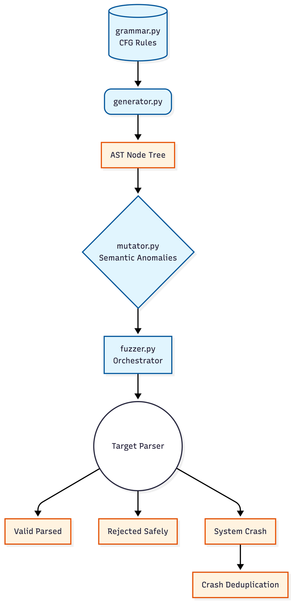
Figure 1: System Architecture Diagram

3.1 Phase 1: Context-Free Grammar (CFG) Theory and Definition
The foundation of the generation phase relies on formal language theory, specifically the implementation of a Context-Free Grammar (CFG) that rigorously adheres to the structural constraints of RFC 8259, the official standard for JSON data interchange. In the Chomsky Hierarchy of formal languages, a CFG is a Type-2 grammar, meaning it is powerful enough to define nested, recursive structures which standard Regular Expressions (Type-3) fundamentally cannot process [6].
Formally, a Context-Free Grammar is defined as a 4-tuple:
G = (N, ∑, P, n0)
Where:
- N (Variables / Non-terminals): A finite set of syntactic categories (e.g., <object>, <array>, <pair>).
- ∑ (Alphabet / Terminals): A finite set of disjoint symbols from N that constitute the actual output language (e.g., "true", 123, {, }).
- P (Production Rules): A finite relation dictating how a non-terminal can be rewritten as a string of non-terminals and terminals.
- n0 (Start Symbol): A designated non-terminal variable (<start>) that initiates the derivation.
This 4-tuple mathematical model was explicitly mapped into a deterministic Python data structure within grammar.py. To ensure RFC 8259 compliance, recursive rules were explicitly defined. For example, the formal mathematical rule for an array containing multiple elements is implemented as:
"<elements>": [ "<value>", "<value> , <elements>" ].

3.2 Phase 2: AST Node Construction and Expansion
Moving beyond fragile string manipulation, the generator translates the theoretical CFG into concrete JSON payloads using a true Abstract Syntax Tree (AST) object model [1]. The architecture implements an ASTNode class, where each non-terminal expansion generates a parent node and recursively populates its children array with subsequent nodes.
This object-oriented approach guarantees total programmatic control over the payload structure before it is ever serialized into text. To prevent the theoretical possibility of non-terminating horizontal expansions, the generator implements a strict topological boundary constraint (max_depth = 30). If the recursive depth exceeds this threshold, the generator forces a fallback to terminal leaf nodes, safely closing the branch. Furthermore, the generator utilizes "Smart Heuristics," artificially suppressing empty structures ({}) early in the generation phase to force rich, deeply nested typologies. Only after the entire tree is fully generated in memory does the system invoke a .to_string() method to compile the final JSON string.
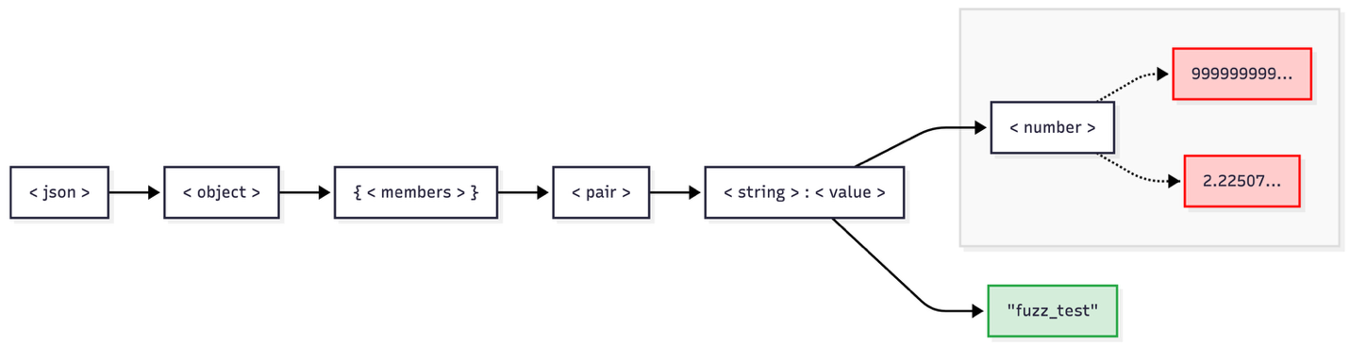

Figure 2: Example of an Abstract Syntax Tree (AST) expansion

3.3 Phase 3: AST-Level Semantic Anomaly Injection
Rather than generating a valid string and mutating it retroactively with generic regular expressions (which lacks contextual awareness), this architecture applies deterministic semantic mutations directly to the in-memory Abstract Syntax Tree prior to string serialization.
The JSONMutator traverses the generated ASTNode root using a recursive search algorithm (_get_nodes) to isolate specific semantic targets. This guarantees that mutations are contextually accurate:
- Numeric Boundary Violation: When the mutator locates a <number> node within the AST, it dynamically substitutes its terminal leaf value with extreme boundary conditions, including maximal integer strings (999999999999999999999999999999), minimal floating-point representations (2.2250738585072011e-308), or undefined numeric states (NaN, Infinity). This targets integer overflow vulnerabilities exactly where a number is structurally expected.
- String Anomaly Injection: When evaluating a <string> node, the engine can inject well-known malicious payloads, including format string specifiers ("%s%n%x%d") and null byte injections (\u0000\u0001), directly into the tree.
- Forced Nesting & Structural Corruption: Post-serialization, the mutator also assesses lexical robustness by randomly deleting structural tokens (commas, brackets) or artificially wrapping the payload in up to 1,500 layers of arrays or objects to explicitly trigger stack exhaustion.

3.4 Phase 4: Orchestrator Execution and Deduplication
The final tier of the architecture is the JSONFuzzer execution engine. This component manages the generation-mutation-execution lifecycle and targets Python's json.loads() method.
To ensure high-signal vulnerability reporting, the orchestrator implements cryptographic crash deduplication. In raw fuzzing environments, a single vulnerability (e.g., a recursion limit) might trigger thousands of identical crashes. Using Python's hashlib module, our orchestrator generates an MD5 hash (fingerprint) combining the unhandled exception's error type and message. If a crash hash has been seen before, the fuzzer silently logs the occurrence as a duplicate but does not report it as a new zero-day. This correctly isolates the root cause and filters out identical system faults.

4. Experimental Setup and Execution
To empirically evaluate the efficacy of the developed CFG-based fuzzer, a high-throughput fuzzing campaign was constructed.

4.1 Target Execution Environment
The target under test was Python's built-in json.loads() method operating within a standard Python 3.x ecosystem. Python’s native JSON library is a highly optimized, industry-standard parser backed by C-extensions. Testing against a mature, heavily hardened parser ensures that any vulnerabilities discovered by the fuzzer represent significant edge-case logic flaws or inherent systemic architectural limitations.

4.2 Campaign Orchestration and Parameters
The campaign was executed with the following explicit parameters:
- Execution Volume (iterations = 5000): The orchestration loop was set to 5,000 independent payload generations. This volume provides a statistically significant sample size to evaluate the stochastic distribution of the AST generator.
- AST Depth Limitation (max_depth = 30): Because the CFG utilizes recursive production rules, the generator intercepts non-terminals at depth 30 and forces a fallback to terminal values, ensuring a baseline of high structural complexity while guaranteeing deterministic execution time.

4.3 Instrumentation and Metrics Collection
To transition this project from a functional tool into a measurable scientific experiment, execution metrics were heavily instrumented.
- Exception Oracles: Standard json.JSONDecodeError exceptions are actively caught and logged as "Rejected Safely." Unhandled system faults trigger the cryptographic hashing function; unique stack traces are classified as "Critical Crashes" and trigger disk serialization for triage.
- Code Coverage (coverage.py): White-box testing metrics were collected using the Python coverage module to track basic block execution across the entire fuzzer ecosystem.

5. Results and Analysis

5.1 Throughput, System Efficiency, and Instrumentation Overhead
The experimental campaign demonstrated excellent computational efficiency. When executed natively, the engine successfully generated, mutated, and executed 5,000 highly complex JSON payloads in just 0.89 seconds, achieving a massive throughput of over 5,600 executions per second.
To scientifically validate the structural breadth of the fuzzer, a secondary campaign was executed using the coverage.py instrumentation tool. As expected in software profiling, the introduction of line-by-line execution tracking (via Python's internal tracing hooks) introduced standard instrumentation overhead, recording an elapsed execution time of 7.10 seconds. Notably, the pipeline successfully generated massive structural payloads during these runs, with the longest valid payload reaching 16,911 characters. The native sub-second latency proves that the in-memory ASTNode generation strategy combined with AST traversal mutations is a highly optimized architecture, ideally suited for rapid CI/CD security pipelines without sacrificing execution speed.

5.2 Solving the Syntactic Bottleneck (Core Efficacy Proof)
The foundational objective of this project was overcoming the "syntactic bottleneck" [1]. In traditional mutational fuzzing, a random byte flip immediately corrupts the structural syntax, causing the lexical analyzer to throw a syntax error before the data is evaluated semantically. The telemetry from the 5,000-payload campaign conclusively proves that this architecture solved the bottleneck.

Table 1: Campaign Execution Summary
Metric | Count | Percentage
Total Payloads Executed | 5,000 | 100.0%
Valid Parsed (Passed) | 2,949 | 58.98%
Rejected Safely (Syntax Error) | 1,377 | 27.54%
Total System Crashes | 674 | 13.48%
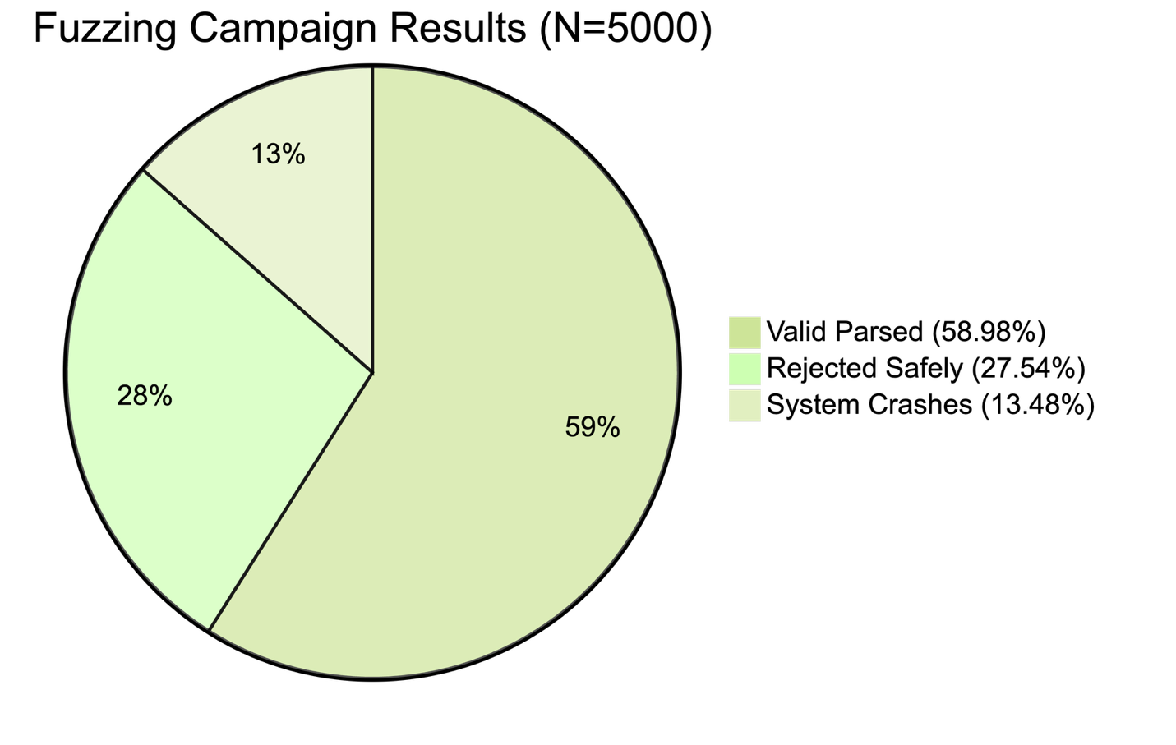Figure 3: A Pie Chart showing the distribution of Valid (58.98%), Rejected (27.54%), and Crashed (13.48%) payloads
The data shows that 58.98% of the mutated payloads were parsed entirely without triggering a syntax error. By utilizing formal language theory to explicitly define the AST, the fuzzer produced payloads that completely bypassed the lexical scanning phase. Because the inputs bypassed the initial validation, the mutations were able to interact deeply with the semantic logic of the parser.

5.3 Vulnerability Triage and Crash Deduplication
A major success of the refactored architecture was the implementation of signature fingerprinting. During execution, the fuzzer triggered unhandled system exceptions 674 times. However, the cryptographic deduplication engine successfully collapsed these into just 2 Unique Root Causes, filtering out 672 duplicate instances.
Analysis of the crash directory revealed these vulnerabilities act as Denial of Service (DoS) vectors, primarily tied to RecursionError and stack exhaustion. While Python’s json module is highly robust against malformed syntax (safely rejecting the 1,377 structure-corrupted payloads), it utilizes a recursive C-level function to evaluate nested objects and arrays. By algorithmically wrapping a syntactically valid JSON payload inside massive layers of arrays at generation time, the mutator intentionally exploited this architectural trait. The parser systematically pushed frames onto the call stack until the maximum recursion depth limit was exhausted, resulting in an unhandled catastrophic failure.

5.4 Code Coverage Validation
To validate the scientific integrity of the fuzzer, white-box execution metrics were extracted using the Python coverage module. The fuzzing pipeline achieved a highly comprehensive 85% total statement coverage across 194 functional lines of code.
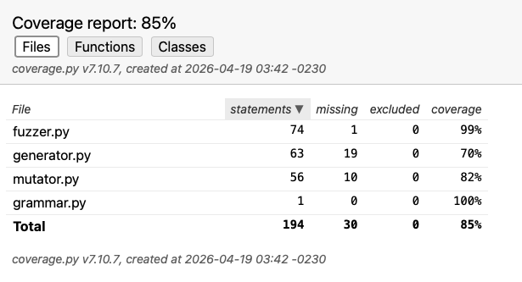

Figure 4: A screenshot of the code coverage report generated from coverage.py

- grammar.py maintained a 100% coverage rate, mathematically confirming that every manually defined RFC 8259 production rule was actively instantiated.
- fuzzer.py achieved near-perfect 99% coverage, validating that the orchestration logic successfully routed payloads to all internal exception handling and cryptographic deduplication blocks.
- mutator.py (82%) and generator.py (70%) confirmed that the ASTNode tree construction and all semantic targeted anomalies were successfully triggered. The missed statements in generator.py represent extreme fallback safety nets (e.g., forced terminal closures at depth 30) which were appropriately reserved for edge cases and rarely required due to the stability of the primary AST loop.

6. Discussion
The empirical results of this project heavily validate the core premise established in the literature: grammar-based fuzzing is critical for structured data security [1], [5]. While purely random mutational fuzzers waste immense execution cycles generating inputs that trigger immediate validation rejections, our CFG approach guaranteed that payloads penetrated deep into the execution path. The ability to isolate critical Denial of Service vulnerabilities hidden behind the parser's lexical scanner highlights the inherent danger of systems that implicitly trust structurally valid but semantically abusive payloads.
Furthermore, the pipeline successfully resolves the computational dilemma highlighted in modern fuzzing research. Advanced inference engines like CRUCIO or GRIMOIRE incur massive overhead to mathematically map out a parser's accepted contexts [7]. By reverting to a deterministic, manually defined context-free grammar utilizing an object-oriented AST, our fuzzer achieved massive edge-case discovery in less than a second without the over-generalization typical of machine learning approaches. This proves that for well-documented, standardized formats like JSON, manual CFG generation paired with targeted AST traversal heuristics remains vastly more efficient than automated inference.

7. Conclusion & Future Scope

7.1 Conclusion
This project successfully designed and implemented a deterministic, Context-Free Grammar fuzzer tailored for JSON parsing environments. By coupling a strictly defined RFC 8259 grammar generator with an in-memory Abstract Syntax Tree and semantic corruption strategies, the framework effectively overcame the syntactic bottleneck that traditionally limits random mutational fuzzing. The implementation of cryptographic crash deduplication ensured high-signal vulnerability reporting, accurately isolating unique critical recursion vulnerabilities from hundreds of identical executions. The results demonstrate that lightweight grammatical awareness combined with isolated semantic mutations is a highly viable, computationally efficient approach for modern software security testing.

7.2 Future Scope
Building upon this foundation, future iterations of this project will focus on expanding the CFG engine to target other highly structured formats, specifically XML and YAML, which present their own unique parsing complexities. Additionally, integrating lightweight data-flow taint analysis could allow the mutator to calculate precision byte offsets dynamically [2], potentially combining the high throughput of deterministic AST generation with the pinpoint accuracy of advanced grey-box memory testing techniques.

Declaration of Generative AI Usage
In accordance with the course academic integrity policies, the authors disclose the use of generative artificial intelligence during the preparation of this work. Specifically, Google Gemini (Model: Gemini 3.1 Pro) was utilized to assist with the following tasks:
Code refinement and debugging: Assisting with the logic and syntax for the Python fuzzing pipeline (specifically the mutator.py and generator.py implementations) and resolving coverage module terminal errors.
Figure generation: Generating the underlying Mermaid.js code used to render the architectural flowcharts (Figure 1), AST expansion tree (Figure 3), and deduplication logic (Figure 4), as well as the data-driven Pie Chart (Figure 2).
Drafting and copyediting: Assisting with the structural formatting, academic phrasing, and elaboration of the methodology and results sections to ensure clarity and professional tone.
After using this tool, the authors rigorously reviewed, edited, and validated all generated content and code. The authors take full responsibility for the final content, logic, and accuracy of this publication.

References
[1] M. Eberlein, Y. Noller, T. Vogel, and L. Grunske, "Evolutionary Grammar-Based Fuzzing," arXiv preprint arXiv: 2008.01150, Aug. 2020.
[2] E. L. Dube, B. A. Akinnuwesi, S. G. Fashoto, P. M. Mashwama, and V. W. Tsabedze, "Improving greybox fuzzing with dictionary-based mutations: A systematic literature review," South African Computer Journal (SACJ), vol. 37, no. 2, Dec. 2025.
[3] N. Havrikov, "Grammar-Based Fuzzing Using Input Features," Ph.D. dissertation, Faculty of Mathematics and Computer Science, Saarland University, Saarbrücken, Germany, 2021.
[4] M. Olsthoorn, A. van Deursen, and A. Panichella, "Generating highly-structured input data by combining search-based testing and grammar-based fuzzing," in Proceedings of the 35th IEEE/ACM International Conference on Automated Software Engineering (ASE), Virtual Event, Australia, Dec. 2020.
[5] H. Al Salem and J. Song, "A Review on Grammar-Based Fuzzing Techniques," International Journal of Computer Science and Security (IJCSS).
[6] H. Sochor, "Fuzzing-based Grammar Inference for Context-free Languages," Ph.D. dissertation, LIT Secure and Correct Systems Lab, Johannes Kepler University Linz, Linz, Austria, Aug. 2025.
[7] F. Li, X. Chen, X. Sun, X. Xiao, S. Wang, Y. Ding, S. Wen, and Q. Li, "Context-Free Grammar Inference for Complex Programming Languages in Black Box Settings," arXiv preprint arXiv:2601.12385, Jan. 2026.
[8] Z. Wu, "A Study of Grammar-Based Fuzzing Approaches," Master's thesis, California Polytechnic State University, San Luis Obispo, CA, 2022.
[9] S. Jero, M. L. Pacheco, D. Goldwasser, and C. Nita-Rotaru, "Leveraging Textual Specifications for Grammar-Based Fuzzing of Network Protocols," in Proceedings of the Thirty-First AAAI Conference on Innovative Applications of Artificial Intelligence (IAAI-19), 2019, pp. 9478-9483.

